Fall Detection Using Pose Estimation models And Smart Alarming System

Prof.Deepali Joshi  
 *Department of Information Technology & MCA.*  
 *Vishwakarma Institute of Technology*Pune, India  
deepali.joshi@vit.edu

Sanika Salunke  
 *Department of Information Technology & MCA.*  
 *Vishwakarma Institute of Technology* Pune, India sanika.salunke19@vit.edu

Shreyas Mendhekar  
 *Department of Information Technology & MCA.*  
 *Vishwakarma Institute of Technology* Pune, India shreyas.mendhekar19@vit.edu

Abhinav Shambharkar  
 *Department of Information Technology & MCA.*  
 *Vishwakarma Institute of Technology* Pune, India abhinav.shambharkar19@vit.edu

Vallabh Niturkar  
 *Department of Information Technology & MCA.*  
 *Vishwakarma Institute of Technology* Pune, India vallabh.niturkar19@vit.edu

Bhagwat Shinde  
 *Department of Information Technology & MCA.*  
 *Vishwakarma Institute of Technology* Pune, India bhagwat.shinde19@vit.edu

***Abstract*—The number of aged people is constantly increasing in India and other countries widely as India saw a rise in the older population from 8.6% in 2011 to 10.1% in 2021 and it will be 13.1% in 2031.This can infer that the older population will increase rapidly. There should be a model which detects falls of these old aged persons because at any moment they can fall.**

**In this proposed model there are 3 phases which are pose estimation, fall detection, and alarming system. In pose estimation, this proposed model used OpenPose, PoseNet and MoveNet.Fall detection has been identified by an abrupt change in the position of a person’s coordinates calculated by pose estimation models and for the alarming system proposed model used a WhatsApp chatbot and mobile phone calling for alarming the corresponding person.**

***Keywords—OpenPose, MoveNet , PoseNet***

# Introduction

By 2030, 1 in 6 people in the world will be aged 60 years or above.The share of the population aged 60 years and above will increase from 1 billion in 2020 to 1.4 billion by 2050 and the world’s population will double (2.1 billion).The person aged more than 80 and above will also increase and triple the current population by 2050.[1]

The above data infer how important fall detection is for aged people as their numbers are increasing day by day. This proposed system will create a care system for aged people and this will increase timely medical intervention, and give older people a sense of security and confidence, thus prolonging their independence. This report mainly focuses on the problem we discussed.

We have created a system to detect fall using pose estimation models. Senior citizens and disabled people can find some daily task difficult to perform because of fear of falling or lack of fast medical help to be given to them. They have difficulty moving independently and sometimes fall. Also, delaying treatment after a fall increases the chance of serious injury. To overcome this challenge we have proposed a model that can be used to detect fall in a room where the system is placed and alert the users relatives or caregivers to provide the treatment. This system is different from the traditional approaches because we have used the concept of pose estimation to detect the fall. Also some of the products require physical devices to carry every time to detect fall.

# Literature Review

This paper explains the medical application model for robots to detect elder person fall detection. It shows how they solved multiple challenges like the proper formation of bounding boxes and problems with foreground segmentation. In this paper, they used the FT lying person dataset ( consisting of 507 samples and 21 subjects). The results in the proposed paper show that the part-based model significantly outperforms the global model based on the same feature type for lying pose detection.

Review of fall detection techniques

Different ML/DL/IOT-based techniques are used in different devices like wearable watches, IoT smart home devices, and smart camera-based models. The kinematic Sensor based approach is more effective than any other technique as per the survey.

Deep Neural Networks for Real-Time Remote Fall Detection. In this paper, the author discussed DL-based models for pose detection i.e CNN and RNN. In real-time detection, it takes 17 key points of body parts ( which are obtained from POSENET ) as input and detects them based on those 34 values.

Deep Learning-Based Human Pose Estimation: A Survey

This paper provides a comprehensive overview of current deep learning-based solutions for 2D and 3D pose estimation through systematic analysis and comparison of the solutions.The survey documents over 250 of his research papers since 2014.

Review of Fall Detection Techniques: A Data Availability Perspective - In this paper, the focus of this research is away from conventional approaches, from detection that relies on the assumption that sufficient fall data are available. They mentioned that falls are an infrequent, abnormal activity. In situations like this, where fall data is highly skewed or missing, machine learning approaches other than traditional supervised classification should be considered.

# Project Flow Diagram

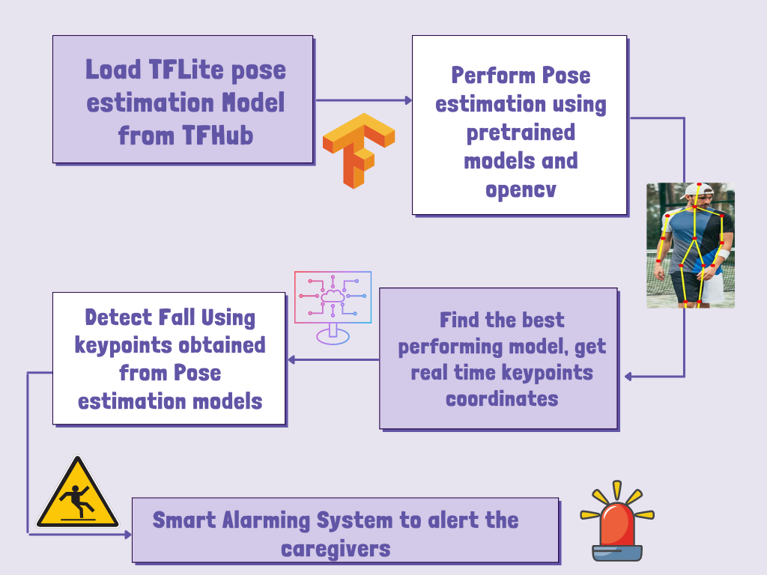

Fig 1. Project Flow diagram

1. Proposed Methodology

In this proposed system we used pose estimation models to detect the keypoints in the human body. For this we used four different models - MoveNet, PoseNet, OpenPose and Yolov7. We did a detailed study on how these models work and provide the output of keypoint coordinates within an input frame. These pretrained models are open to all and hosted on Tensorflow-Hub to use in the applications.

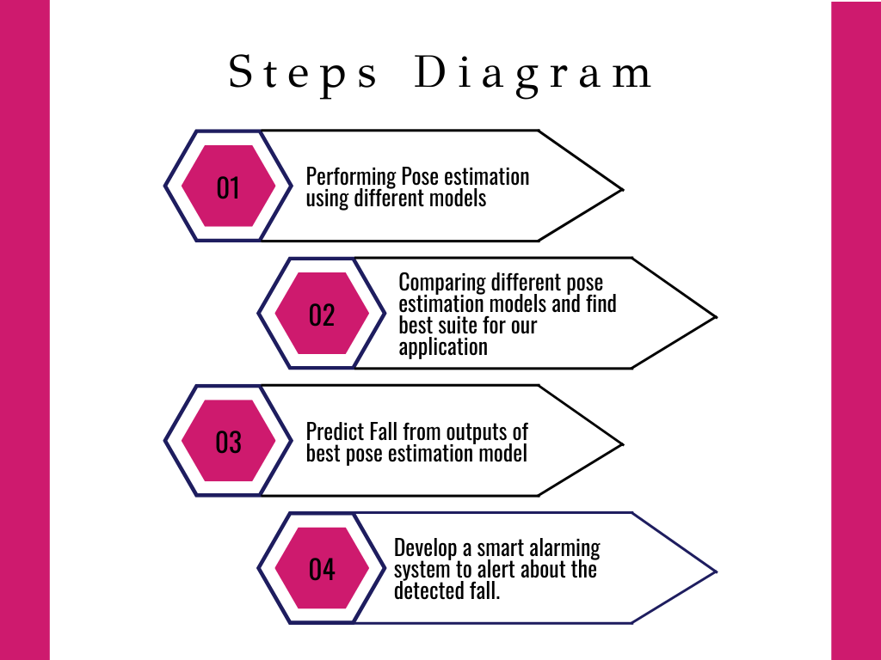

In computer vision pose estimation in humans is a technique to predict the joints or keypoints in the human body. This prediction of body joints or keypoints can be done by defining this keypoints like ear,nose,shoulder,knees,wrists etc. This approach reduces the work by not using the traditional method of training the model using a large dataset and improves the accuracy and speed by first estimating the pose of humans in the frame and then detecting the fall by analyzing the coordinates of keypoints returned by the model.

We have divided the given problem statement into three parts like pose estimation, fall detection and smart alarming system.

1. Pose Estimation :

Pose estimation is a computer vision technique that recognizes people and objects in images and videos, such as identifying where a person's elbows are visible in an image. Pose estimation techniques have many applications, including gesture control, action recognition, and augmented reality.

For pose estimation we used four different models which were hosted on Tensorflow-Hub. These models are MoveNet, PoseNet, OpenPose,and YoloV7.

1. MoveNet :

MoveNet is one of the pose estimation models offered on TF Hub. It is a fast and accurate model that is used to estimate human pose with the help of 17 keypoints on a body. It is hosted on TF Hub as a pretrained model and open for all with two variants which are MoveNet Thunder and MoveNet Lightning. Both of these models return 17 keypoints but the difference is that the lightning model is used for latency-critical applications where speed is an essential component. It is faster than the available models for pose estimation. Whereas MoveNet Thunder Model gives the best accuracy. and this model is used where accuracy is very much more important than speed. These models are useful for fitness, sports and health applications.

We can use this models directly client-side in browser using javascript files provided by tensorflow ie. TensorFlow.js without server call requirements. In this way there is no need to install any dependencies. We can also use the tflite pretrained model to deploy the model in an application or hardware. It is used to run models on mobile, embedded, and edge devices.

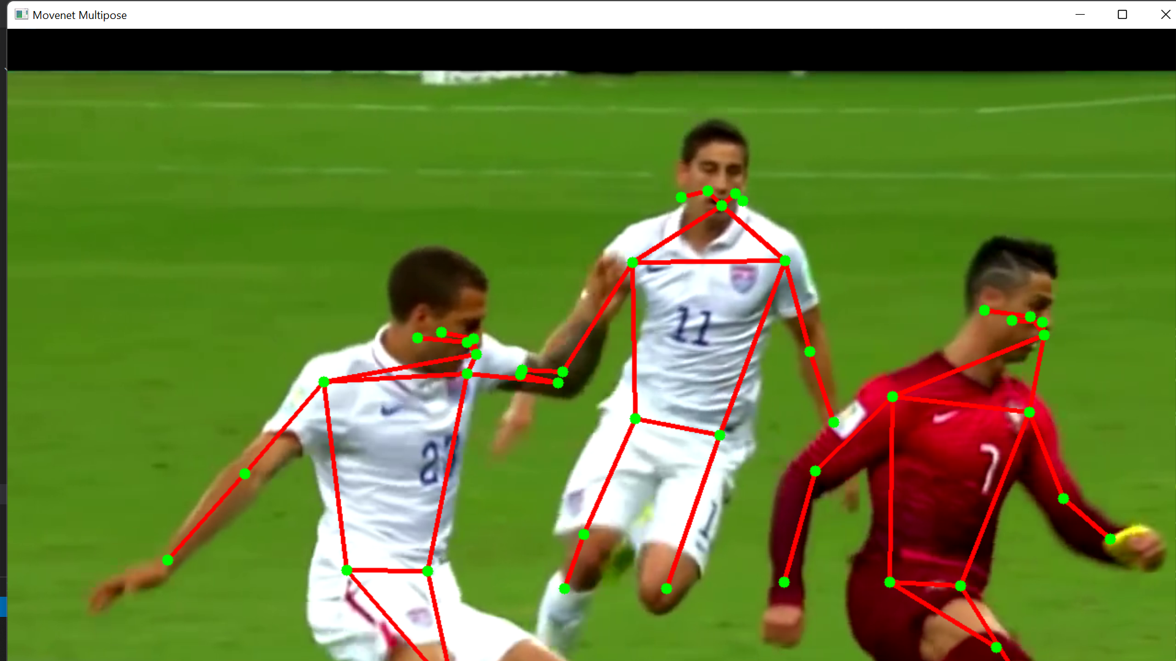

(Multi-Pose Estimation Using MoveNet)

The difference between the Multipose and Singlepose model is that as the name suggests the Multipose model is able to detect multiple people in the frame while the Singlepose model can detect only a single person at a time inside a given frame.

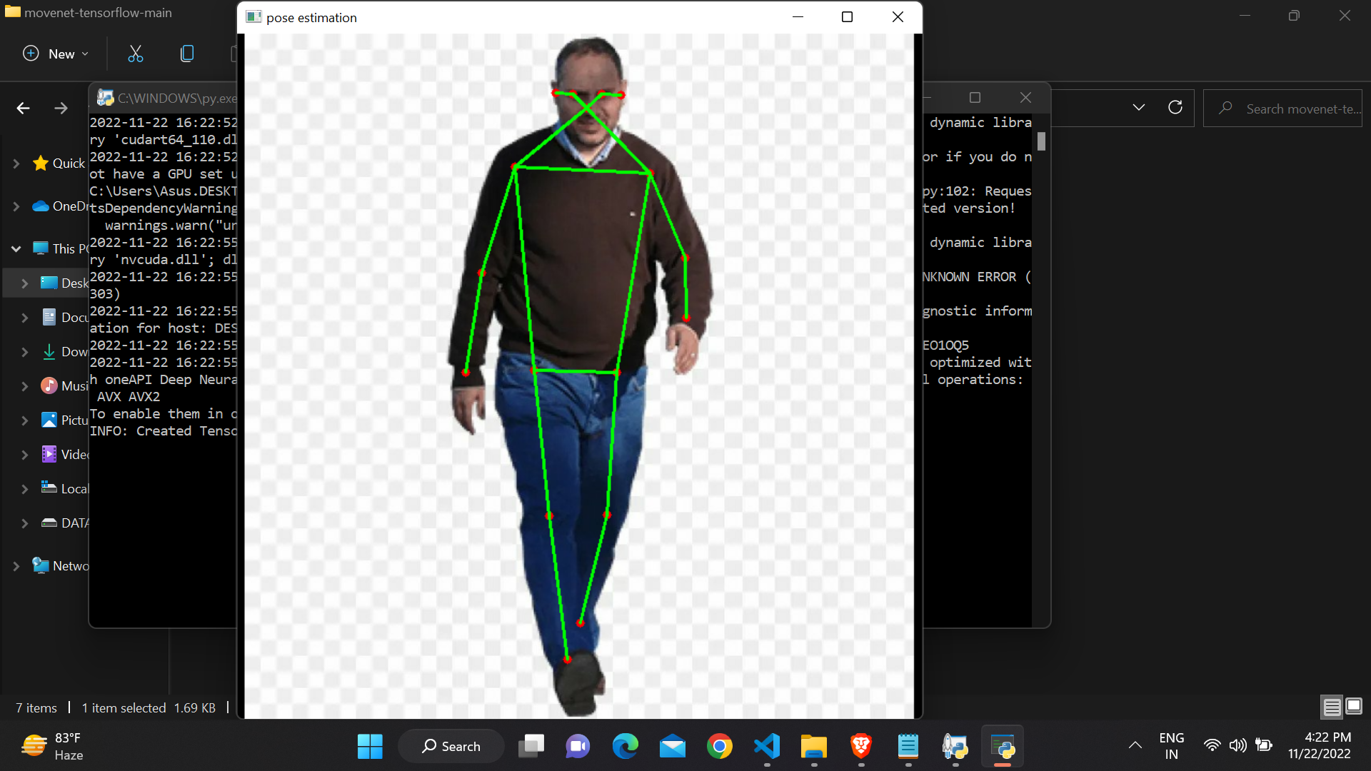 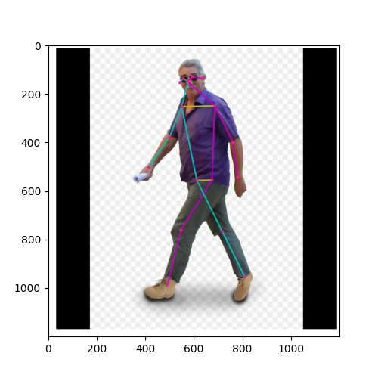

(MoveNet Lightning) (MoveNet Thunder)

Above images show the output from different MoveNet models like singlePose Lightning , Thunder and MoveNet Multipose model. This shows the identification of different keypoints in the human body. We have used these Keypoints to detect fall by finding drastic changes in the coordinates of a user's keypoints.

1. OpenPose :

The very first multi-person system to detect human body joints. It detects overall body keypoints total 135 on a single input image. The increasing number of machine learning algorithms needs 2D pose estimation models. OpenPose helps in detecting human body points and facial keypoints on single images. This model can run on different systems and also provides various hardware support like cpu, gpu etc. Also it is compatible with input images and webcam input to the models.

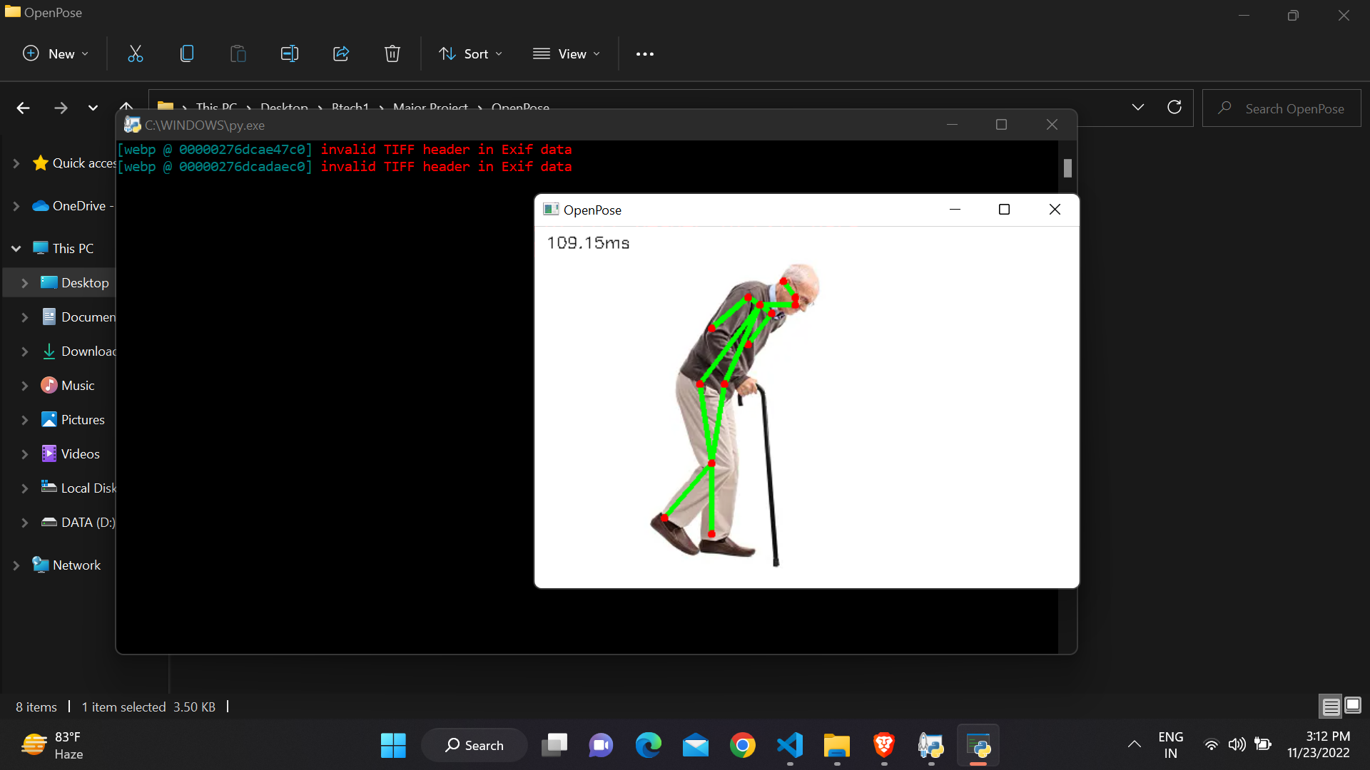

(Pose Estimation Using OpenPose)

1. PoseNet

PoseNet uses a convolutional neural network model to regress poses from a single RGB image. It can also be used in real-time systems that offer 5ms/frame rates. Posenet is a real-time position detection technology that can detect human positions in images and videos. This works for both single-mode and multi-position detection cases. Simply Posenet is a deep learning TensorFlow model that detects body parts such as elbows, hips, wrists, knees, and ankles and connects these points to create a skeletal pose structure that allows estimation of human posture. PoseNet is trained on the MobileNet architecture which is a convolutional neural network developed by Google and trained on the ImageNet dataset. It is mainly used for classifying images into categories and estimating the target. It is a lightweight model that uses depth-separable convolutions to deepen the network, reduce parameters, computational cost, and improve accuracy. Anyone with a limited laptop/desktop configuration can easily use such a model to create great projects.

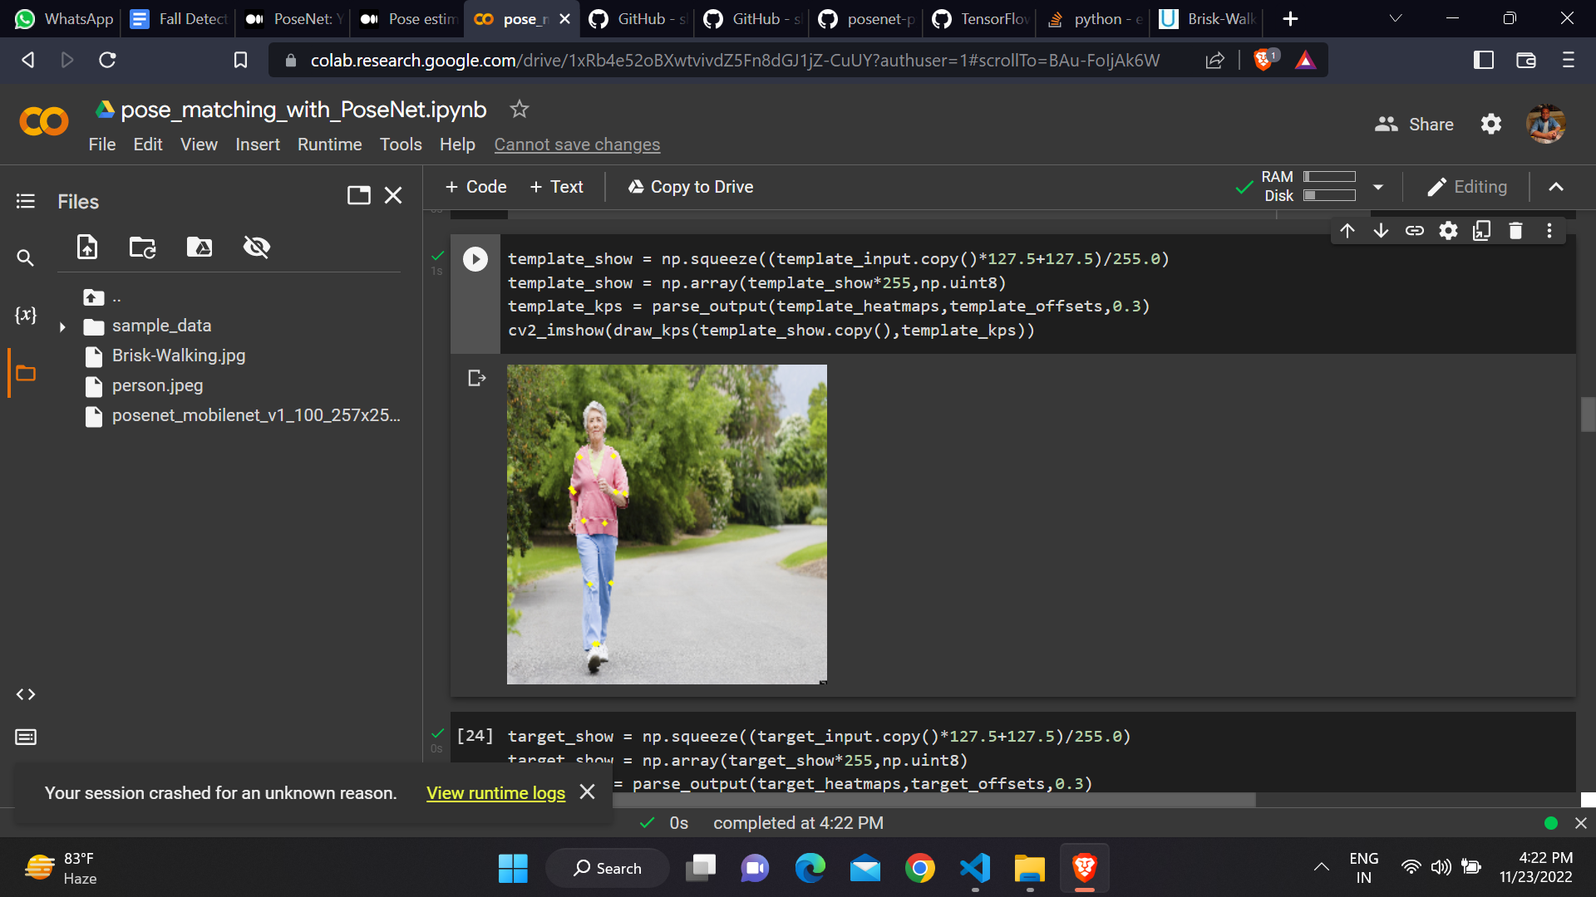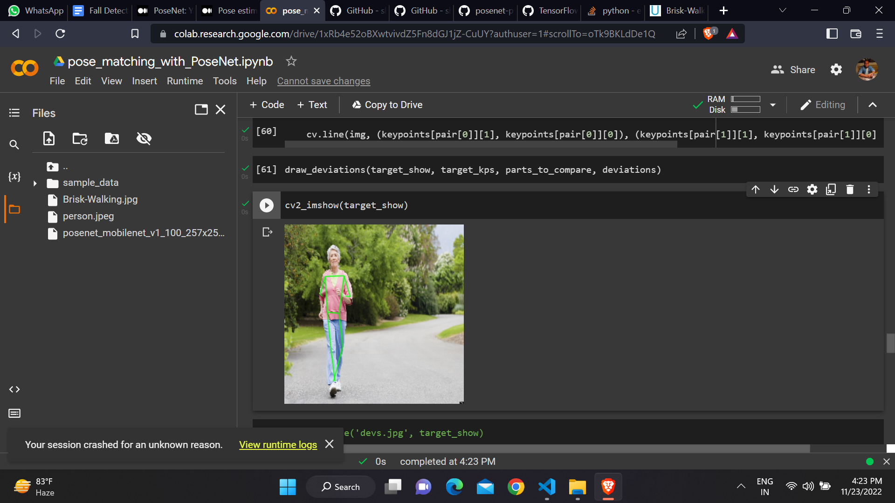

(Pose Estimation Using PoseNet)

1. YOLOv7

YOLOv7 is more than just an object detection architecture. It provides a new model that can output keypoints and perform instance segmentation, as well as bounding box regression, which was not standard in the previous YOLO models. This is not surprising as many object detection architectures were reused for segmentation and keypoint detection tasks etc. due to common general architectures with different outputs depending on the task. Not surprisingly, its support for instance segmentation and keypoint detection is likely to become the new standard for YOLO-based models, surpassing virtually all other two-stage detectors a few years ago. This is a one-stage posture estimation model for multiple people. YOLOv7's poses are unique because they depart from traditional two-stage pose estimation algorithms. Reducing the complexity of single-layer models is expected to result in faster and more efficient models.

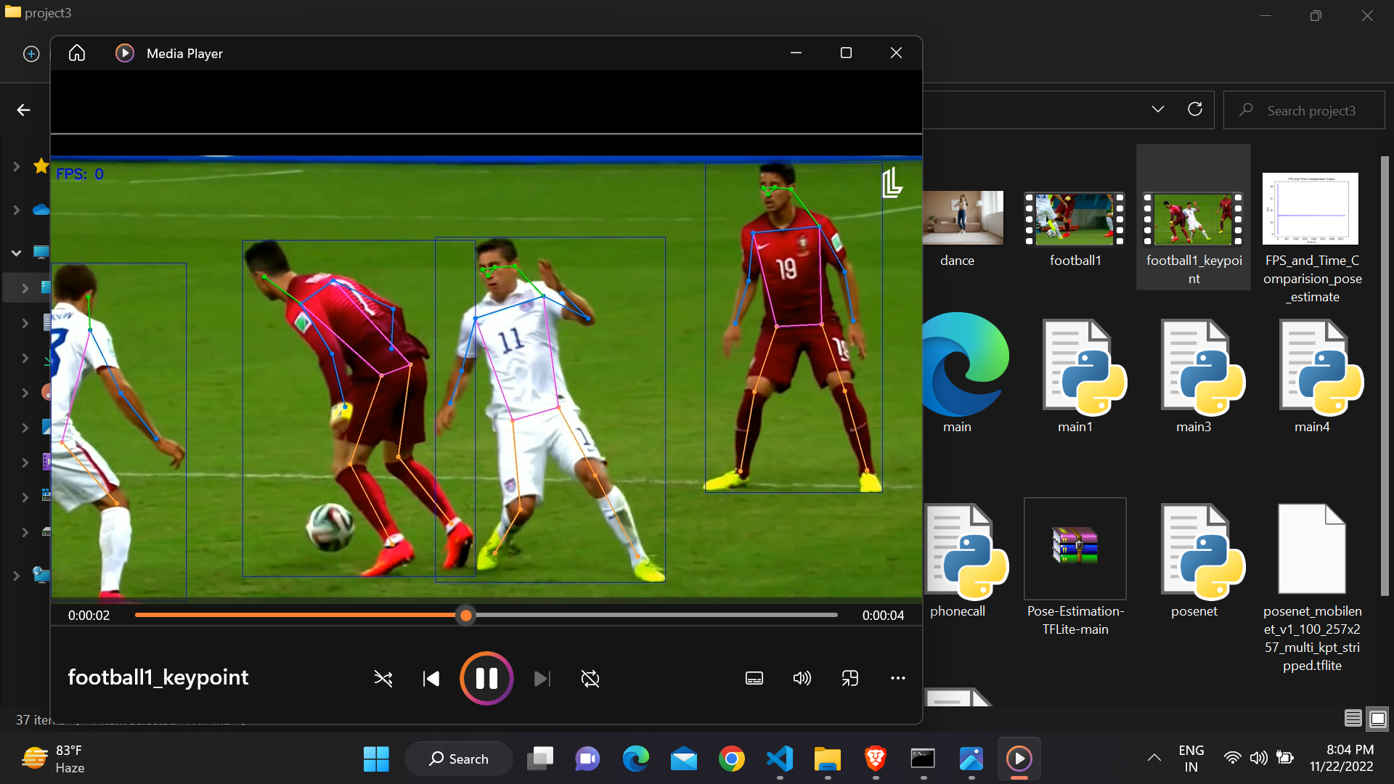

(Pose Estimation Using Yolov7)

B. Fall detection :

We have performed fall detection after keypoints with scores received from our pose estimation models. As discussed, we have used outputs from the MoveNet Lightning model because this model is very fast. We need quick results from the pose estimation models to provide immediate medical care to the users. We got outputs in form of keypoints, for the MoveNet lightning we got x and y coordinates of that 17 keypoints with the confidence score of that keypoint. That keypoints will be mainly used to detect the fall. We have used keypoints from the shoulder and nose to detect the drastic change in the coordinates of the shoulder and nose.

If we find a drastic change in the coordinates we can say a person is experiencing a fall. There are many conditions in our daily activities where we need to lie down to perform some tasks. For those conditions we can’t show drastic changes. But if we see drastic changes in the coordinates it is considered to be a fall. Sometimes we can even produce false responses because of these dynamic coordinates changing frequently. To solve this problem we need to be more specific about the time taken and the change in coordinate relation when someone experienced a fall. As soon as we get an output from the fall detection method we need to quickly process the next step i.e. smart alarming system.

C. Smart Alarming System :

In this part we have added a feature to call and message to the relative or caregiver when fall is detected at the place where our model is placed. This feature is very important as this will reduce the response time to give first aid and medical help whenever necessary. For this part we have used Twilio. Twilio is a Software which provides programmable communication tools to make calls and send or receive messages. We have used their whatsapp messaging system and phone call system to alert the caregivers and relatives about the detected fall.

It will send a real time image of a frame for detected fall via Whatsapp to check if the system predicted the right fall or not. also it will call the registered number to alert the user.

It will also play a computer generated audio message after receiving the call to let the user know about the fall detected. We have also added the feature for if the person who experienced fall but he/she is still able to communicate or walk then he/she will update the status about their status in the system indicating that the user is fine.

1. Comparative analysis

We have used four different pose estimation models which are MoveNet, Openpose, Posenet and YOLOV7. We have found that the MoveNet Models give the fastest results and specifically the MoveNet Lightning model is very fast as compared to the other models. The MoveNet thunder model gives better accuracy than the Lightning model but it is slow as compared to the Lightning model. We have performed multiple person pose estimation using the MoveNet, Openpose and Yolov7 models and found that these models can perfectly detect the multiple person in the given input frame. Openpose can detect multiple people in a frame but it is much slower than the MoveNet model. We have compared these models on both input images as well as on real time camera inputs. The yolov7 model is the latest model used for object detection and this model also provides a new model to perform pose estimation which provides keypoints as output and perform instance segmentation besides only bounding box regression which was not available with previous versions of yolo (You only look once).



( Pose estimation models )

1. Results And Discussion

In this proposed model we have compared the different pose estimation models and we have studied the speed and accuracy of these pose estimation models. From the results obtained from these pose estimation models we have made a conclusion that the MoveNet Lightning model is the fastest model to be used for our problem statement. Specifically discussing the MoveNet model we have concluded that the Lightning is the fastest and the thunder is with high accuracy. We performed multipose estimation also to check if the models can work on multiple people in a single input image. We have also covered the fall detection using the keypoints obtained from the pose estimation models and compiled all of the stages mentioned in the project flow to create an overall fall detection and smart alarming system using pose estimation models.

1. Conclusion And Future Scope

The report mainly focuses on the analysis and the classification of the pose estimation models. We have mainly covered the 4 pose estimation models and we did the comparative analysis of these models. Based on the results we got from the pose estimation models we have performed fall detection for a given input images and video frames. We have also made a smart alarming system using twilio to alert the users' relatives or caregivers about the fall detected in the given area.

From the above study we have found that the MoveNet Lightning model is the best fit for our application because the MoveNet lightning model is the fastest between all of these models and the openpose model is very slow. The fall detection application we have developed requires high speed to alert the person very quickly.

In the proposed work as mentioned earlier we have developed a logic to identify the fall from the given keypoints after performing pose estimation but we can train another model to do this fall detection task. This can improve the accuracy as well as maintain the speed of the given project.

##### References

1. Computer vision-based fall detection methods using the kinect camera: a survey [https://www.slideshare.net/IJCSITJournal1/computer-visionbased-fall-detection-methods-using-the-kinect-camera-a-survey](https://www.slideshare.net/IJCSITJournal1/computer-visionbased-fall-detection-methods-using-the-kinect-camera-a-survey-123585032?from_action=save) Nov. 21, 2018
2. Nikita Vidua , Prof. Avinash Sharma [Analysis of Fall Detection Systems: A Review] [https://www.slideshare.net/ijtsrd/analysis-of-fall-detection-systems-a-review](https://www.slideshare.net/ijtsrd/analysis-of-fall-detection-systems-a-review?qid=c4f69517-1529-48f8-ac2e-163c50fc4934&v=&b=&from_search=10) - Jan. 06, 2020
3. Dementia Patient Activity Monitoring and Fall Detection using IoT for Elderly [https://www.slideshare.net/ijtsrd/dementia-patient-activity-monitoring-and-fall-detection-using-iot-for-elderly](https://www.slideshare.net/ijtsrd/dementia-patient-activity-monitoring-and-fall-detection-using-iot-for-elderly?qid=f8b0ee28-391d-4867-9308-bff1a37f8334&v=&b=&from_search=9) Jul. 05, 2019
4. [ Deep Learning-Based Human Pose Estimation: A Survey ] <https://arxiv.org/search/cs?searchtype=author&query=Shen%2C+J> *24 Dec 2020*
5. Jesse Hoey and Shehroz S Khan [ Review of Fall Detection Techniques: A Data Availability Perspective ] <https://www.researchgate.net/publication/303680795_Review_of_Fall_Detection_Techniques_A_Data_Availability_Perspective> January 2017
6. Francy Shu & Jeff Shu [ An eight-camera fall detection system using human fall pattern recognition via machine learning by a low-cost android box ] -28 January 2021
7. Shikha Rastogi & Jaspreet Singh [ A Comprehensive Study of Pose Estimation in Human Fall Detection ]

<https://link.springer.com/chapter/10.1007/978-981-19-1142-2_31> 03 July 2022

1. BeomJun Jo, SeongKi Kim [ Comparative Analysis of OpenPose, PoseNet, and MoveNet Models for Pose Estimation ] <https://oa.mg/work/10.18280/ts.390111>
2. Abderrazak Iazzi,Mohammed Rziza,and Rachid Oulad Haj Thami [Fall Detection System-Based Posture-Recognition for Indoor Environments]

<https://www.ncbi.nlm.nih.gov/pmc/articles/PMC8321307/> 2021 Feb 26

1. LINGMEI REN AND YANJUN PENG [ Research of Fall Detection and Fall Prevention Technologies: A Systematic Review ] <https://ieeexplore.ieee.org/stamp/stamp.jsp?arnumber=8736227> June 7, 2019

# 